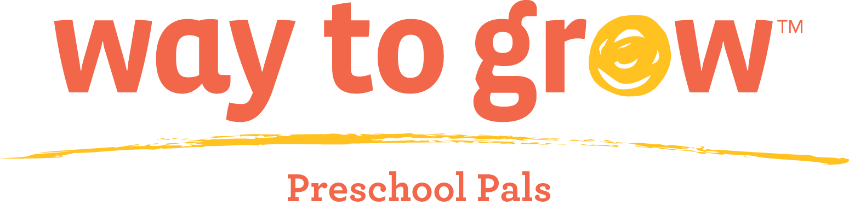

Family Handbook

Preschool Classes
AM Class 8:00 am to 10:30 am
PM Class 12:30 pm to 4:15 pm
Monday, Tuesday, Wednesday, Friday

Revised August 1, 2023
By Nichole Jensen, Manager of Education

Table of Contents

Topic | Page Number
Welcome | 3
Mission | 4
Philosophy | 4
Application and Admission | 4
Tuition and Scholarships | 5
Health Care Summary and Immunizations | 5
Attendance Policy | 5
Parent Pick Up/Drop Off | 6
Consequences for Lateness | 6
Busing Rules and Expectations | 6
Family Engagement Policy | 7
Program Surveys | 7
Referral for Services | 8
Individual Child Care Program Plan | 8
Curriculum and Instruction | 8
Playground Facilities | 9
Field Trips | 9
Nap and Rest Policy | 10
Animals in the Classroom | 10
Behavior Guidance | 10
Prohibited Actions | 11
Separation from the Group | 12
Separation Reports | 13
Persistent Unacceptable Behavior | 13
Child and Adult Care Food Program | 13
Civil Rights Statement | 14
Health Policies | 14
Allergy Policy | 15
Exclusion for Illness | 15
Medications | 16
Videos, Photographs, Public Relations, and Website | 17
Media | 17
Program Grievance Procedure for Parents | 17
Maltreatment of Minors Mandated Reporting Policy | 18
Family Handbook Agreement | 24

Welcome
Welcome! Thank you for enrolling your child in the Way to Grow Preschool Pals program. We are a center-based preschool program that is licensed by the Minnesota Department of Human Services as a childcare center. We are also rated as 4 Stars in the Minnesota Parent Aware Quality Rating System and are accredited through the National Association for the Education of Young Children (NAEYC). As such, we must follow the rules and standards of all three organizations.

Way to Grow serves children that turn three by September 1 of the current school year up to the child’s first day of kindergarten. The classroom is licensed for 20 children. The classes are held on Mondays, Tuesdays, Wednesdays, and Fridays of each week. We are a year-round program with weeks off for spring break, winter break, break before the summer program, and break before the fall program. The younger children (two years before kindergarten admission) meet in the morning from 8:00 – 10:30 AM. The older children (one year before kindergarten admission) meet from 12:30-4:15 PM.

The Way to Grow staff members consist of a Lead Teacher, an Assistant Teacher, and a Classroom Aide. There is also a Bus Driver which provides transportation to and from our program for many of our families. In addition, there is a Director of Education and an Education Coordinator that office at the Way to Grow corporate headquarters. Finally, the Education Coordinator and some of the Family Educators are trained to serve as Substitutes for the preschool. In fall 2021, we welcomed a Reading Corps member to work with the afternoon class.

We are looking forward to surrounding your child with developmentally appropriate opportunities for learning and growing. Our educators will be sensitive to your child’s needs while encouraging your child to learn through educational activities structured on routine and practice. In our program you will witness your child’s self-esteem soar to new heights with each skill learned.

The success of your child’s early learning within Way to Grow is rooted in cooperation and collaboration between the staff in our program and the adults in your child’s home. The policies outlined in this handbook demonstrate what you can expect from Way to Grow and what we hope to learn from you.

By partnering with schools and the community, Way to Grow engages diverse families in order to nurture and prepare their children for school and life success. Our core philosophy is that parents have primary responsibility for teaching their children. Way to Grow helps parents gain knowledge and skills, as well as access to resources to support them in their roles as their children’s first and most important teachers. By helping parents prepare their children for school, Way to Grow prepares children for life. Way to Grow’s preschool programs scaffold parents’ engagement in their child’s education. It informs parents about the type of involvement in school and children’s learning that is necessary for success in kindergarten and beyond.

Mission
The mission of Way to Grow is “Working closely with parents and communities, we ensure that children within the most isolated families are born healthy, stay healthy and are prepared for school.” We accomplish this through our evidence-based home visiting program, as well as, through our center-based preschool. All children in the Preschool Pals must be involved in the home-visiting program. Family educators partner with parents and/or primary caregivers to offer information on child development, model positive parent-child interactions, and provide resources and information regarding the health and well-being of the whole family.

Philosophy
The philosophy at Way to Grow is that parents are their child’s first and most important teacher. Way to Grow requires:
- All parents are active and involved with their Family Educator during home visits.
- Each family’s home language and culture is respected. Way to Grow’s Family Educator team consists of individuals from various cultures and currently speaks eight languages. Way to Grow, as much as possible, tries to match the family’s home language and culture with a Family Educator with a similar background and language.
- All parents must attend parent/teacher conferences. Children are not allowed back to the preschool program unless a parent has met with a teacher.
- Parents must attend and participate in six events (field trips or parent/child groups) during the calendar year.
- Children are sent “homework” each week and parents are expected to help children complete this and ensure that it is returned.
- No family is turned away based upon their ability to pay. Almost all families utilize Early Learning Scholarships through the Minnesota Department of Education for their child’s tuition. Way to Grow also offers a sliding fee scale for those families that do not qualify for a scholarship.

Application and Admission
Applications are available from your Family Educator or the Way to Grow office (201 Irving Ave. N. Suite 100 Minneapolis, MN 55405). Applications are welcome at any time throughout the year. Please note that your family must be receiving home-visiting services from Way to Grow to be eligible for the preschool program. We strive to maintain fair gender, age and language ratios. Children must be age 3 by September 1st of the year they are applying for enrollment and must be toilet-trained. We reserve the right to decide that a child needs more socialization before they start in an academic setting.

Our program primarily serves families that live in the north side of the city of Minneapolis. If your family lives outside of north Minneapolis, you are not eligible for transportation and must pick-up and drop-off your child daily.

Tuition and Scholarships
Tuition for Way to Grow Preschool Pals is $625 per month. You will receive a monthly invoice in the mail for tuition. You may mail payment in the form of check or money order. You may also give a check, money order or cash to the teachers or bring it to the Way to Grow office. Families may be eligible for a sliding fee scale that would allow them to pay according to their income.

Way to Grow Preschool Pals families should apply for a Minnesota State Early Learning Scholarship, either Pathway I or Pathway II to help pay for tuition. Way to Grow Family Educators and staff will assist families to choose the best program for their needs and to help families with filling out the forms. Families may also be eligible for a Way to Grow scholarship.

Families receiving a Pathway I Scholarship must provide Way to Grow and the administrator of the program, Think Small, with a two-week notice when leaving the program. No family will be turned away from the program based on income or inability to pay.

Health Care Summary and Immunizations
All children enrolled in the program must have a health care summary on file at enrollment. It must include the date of the child’s most current health examination and it must be signed by the child’s source of medical care.

In addition, an immunization record must be completed for each child upon enrollment. If the child receives additional immunizations while in programming, please make sure to send an updated immunization record to school. If you conscientiously oppose immunizations, you must have a signed waiver that is notarized. This must list all immunizations that you oppose. If the child is inadequately immunized or unimmunized due to a health concern, you must provide a medical exemption signed by the child’s source health provider.

If the program would have an exposure to measles, mumps, rubella, pertussis, polio, and diphtheria and your child is inadequately immunized or unimmunized, the child may be excluded from school during the incubation period. Way to Grow will follow the recommendations of the local health department regarding exclusion and length of exclusion.

Finally, each child must have an emergency card that lists at least two other local people that can pick up your child if you can’t be reached. This would be used in case of illness or emergency. The emergency card also serves as a medical release giving Way to Grow permission to seek medical attention for the child in case of emergency.

Attendance Policy
Children enrolled in Way to Grow Preschool Pals are expected to attend all scheduled classes. Only three unexcused absences are accommodated for each family. Excused absences include illness or family emergency. Families must call a teacher and provide a reason for the absence right away at which point the absence will be deemed excused or unexcused. After three unexcused absences a student may be dropped from the program. Way to Grow Preschool Pals helps prepare families and children for the attendance expectations of kindergarten. We want families to have a 95% attendance rate or higher. Attendance concerns will be handled on a case-by-case basis

Parent Pick Up/Drop Off
- Children should be dropped off in the classroom and signed in by the start of their session.
- Children should be picked up from the classroom and signed out by the end of their session.
- There will be a maximum 10 minute grace period for lateness after the class ends.
- If your child will be dropped off or picked up late, you are required to call the teachers to let them know. Failure to call will be counted as an unexcused absence.

Consequences for Lateness:
- 1st Time: Teacher calls and reminds parent of the policy. Discusses with parent and fields any questions.
- 2nd Time: Teacher calls and sends letter to parent with information regarding both and a reminder on paper of what will happen if the 3rd offense occurs and so on.
- 3rd Time: Mandatory meeting with teachers, Family Educator, parents and the Director of Education to discuss the problem and find a solution. The child may continue coming to school prior to the meeting as long there is no more lateness.

Busing Rules and Expectations
Parents/caregivers should be waiting for bus at least 10 minutes before expected pick-up and drop-off times. A parent/caregiver age 16 or older must walk the child to the bus door. It is unsafe for young children to be sent to the bus alone. The bus driver will wait no longer than 1 full minute at each child’s house as time is needed to ensure children are boarding and buckled safely. We must have timely boarding to prevent children from spending extensive time on the bus and to prevent late arrival to school.

A parent/caregiver is required to place “Stop/Go” sign in their window to indicate child’s attendance at school in addition to calling staff regarding child’s absence. If the bus should pick up the child, place STOP sign in the window. If the bus should NOT pick up the child, then place the GO sign in window.

A parent/caregiver aged 16 or older must also be present to pick up from the bus door each school day. Preschool children will not be released to anyone under 16 years old unless the parent or caregiver is near and visible to the driver. Our driver will not let children off the bus unless someone is there to greet them at drop off. If parent/caregiver over age 16 is not present at bus drop-off, child will be brought to the Way to Grow office at 201 Irving Ave. N. Suite 100 Minneapolis, MN 55405 to wait for parent/caregiver pick-up. This policy is designed to support families. It is in the best interest of the child to end their day positively and be welcomed home daily.

Please note the policy and procedures regarding no-show. “No-show” means that no authorized adult (or authorized person 16 years of age or older) was present to receive child from the bus upon drop-off.
- 1st Time: For 1 no-show incident, parent/caregiver will receive phone call from teachers and a letter to document and confirm the telephone communication.
- 2nd Time: For 2 no-show incidents, parent/caregiver must have meeting with teachers during school hours to discuss problem-solving measures. Child may attend school as long as no other no-show incidents occur. Busing concerns will be handled on a case-by-case basis. A letter will be sent to document and confirm the results of the meeting.
- 3rd Time: For 3 no-show incidents, parent/caregiver must attend meeting with teachers and Director of Education to discuss problem-solving measures. Child may not attend school until meeting has occurred. A letter will be sent to document and confirm final results of the meeting; which may include program dismissal.

Family Engagement Policy
Way to Grow Preschool Pals supports parental involvement to prepare you and your child for kindergarten and the school system. You are expected to attend all 3 Parent-Teacher Conferences and 6 or more parent child classes and field trips. In addition, parents of preschoolers enrolled in Way to Grow Preschool Pals must maintain a minimum of one home visit and one other contact with Way to Grow each month to continue to attend our program.
- Families are welcome to visit the Way to Grow Preschool Pals classroom at any time and are encouraged to join their child’s field trips or to spend part of the day in class with their child for an event or a snack. The parent or legal guardian of a child will be allowed access to their child at any time while they are in Way to Grow’s care.
- Parents/guardians and teachers will meet for formal conferences 3 times a year.
At conferences you will receive a written assessment about your child’s intellectual, physical, social and emotional development. We want to keep you informed of your child’s development and hear from you about what you see at home. Children cannot return to class until the conference has been completed.
- Parent-Child Class attendance and participation are required. Classes will be held four times per year. These dates are noted in your calendar. Please note that transportation is not provided for Parent-Child Class.
- Parent-Child Class is not regulated by DHS licensing, nor is it required to be.
- Families at Preschool Pals may also attend other Way to Grow events and classes such as Cooking Matters, Family Game Night, New Parent Groups, etc. It is required that parents get an additional 30 hours per year of parent education outside of home visits.

Program Surveys
Twice a year, we will ask you to complete a survey about our preschool programming in order to gather your ideas, concerns and suggestions for programming.

Referral for Services
As a child care provider, we continually monitor the development of all children in our care through ongoing observation and recording. We want the best outcomes for all children. Child care providers are considered a primary referral source for early intervention under the federal IDEA special education law. We are required to refer a child in our program who has been identified as having developmental concerns or a risk factor that warrants referral as soon as possible, but in no case more than seven days after identification. While this is a mandate, we want to keep open communication with parents and caregivers about their children and any concerns we have before a referral is made. We can assist the parent with the referral or partner with them in the referral process. Parents are within their rights to refuse any suggested services.

Individual Child Care Program Plan
If a child is enrolled that has special needs or a child that is already enrolled receives a new diagnosis of a special need, Way to Grow will create an Individual Child Care Program Plan (ICCPP). The plan will be in writing and will specify methods of implementation. If the child has developmental disabilities and/or is eligible for case management, the ICCPP will be coordinated with the child’s individual service plan. If the child has been identified as having a delay by the public school district, the ICCPP will be coordinated with the child’s individualized education plan. If the special need has been diagnosed by a physician, psychiatrist, or a psychologist, the ICCPP will be coordinated by reports from the health professional. All ICCPPs will be evaluated at least annually by a health professional and the child’s parent to ensure the child’s needs are being met.

Curriculum and Instruction
The classroom environment is an important learning tool for young children. The environment includes the physical arrangement of the classroom, the schedule for the day, and the curriculum used.

The Preschool Pals classroom is arranged in learning centers. These include:
- Construction (including blocks)
- Creative Arts and Crafts
- Dramatic or Practical Life Activities
- Science
- Music
- Writing center
- Library
- Sensory Stimulation Activities

In addition, the Preschool Pals utilizes the public school playground across the street, weather permitting, or an empty room next door for indoor gross motor play.

Each day, most of the group is bused by Way to Grow and arrive at the same time. The others are dropped off by an adult into the classroom. The group begins with a greeting meeting which includes teacher-directed activities such as reading a book, reviewing the calendar, and/or studying letters and phonetic sounds. The group then moves to a time when children can choose their own activity in the learning centers or small group activities that are guided by the teachers. The children then move to snack time and gross motor time. At dismissal, the children that are provided transportation are walked to the bus while the others wait for an authorized person to pick them up.

Preschool Pals follows a project-based curriculum. The projects are based upon the interests of the children and include investigations via book and computer, field trips and/or guest speakers, and hands-on activities that provide experiences based upon the topic. At the end of each long-term project, the children stage a culminating event in which they demonstrate their learning.

Finally, social-emotional learning, such as sharing, turn-taking, and conflict negotiation skills, are important for young children to learn. These skills are interwoven into all of the children’s learning each day.

Playground facilities
Way to Grow Preschool Pals will use the City View School playground for gross motor play, when the weather is permitting.

Field Trips
Way to Grow takes field trips as part of the curriculum. Field trips enhance your child’s knowledge base and increase their understanding of real-world application for what we learn in the classroom. Parents are always welcome to join us for field trips, but we are not able to bring any siblings with us. Past field trips have included visits to the Children’s Theater productions and SeaQuest in the Rosedale Mall. At times, field trips are used as the culminating event at the end of a project and relate to the investigation.

When a field trip is coming up, a permission slip will be sent home in your child’s backpack. The permission form will tell the date, time, the purpose, and the destination of the field trip. The hours for the field trip will be different than the hours of the regular school day. On field trip days, the Way to Grow bus is not available, so all parents will need to bring their child to and from school.

Staff members will take emergency information for each child, a first aid kit and manual, and attendance information on all field trips. Permission forms will be kept on file. Attendance will be taken frequently. When the children are separated into groups, each group shall be accompanied by a person trained in Pediatric First Aid and CPR and OSHA. While on a field trip, children will have identification on their clothing that states the name of the program and the cell phone number of the Lead Teacher. The Lead Teacher shall carry the cell phone with him/her at all times while on the field trip.

Nap and Rest Policy
Since Preschool Pals has two part-day sessions that meet less than 5 hours per day and is limited in age to preschoolers, children do not take naps or rest during our programming time. If our times would change to include naps or rest, we would follow all policies in Minnesota Rules, part 9503.0050 and Minnesota Statutes, sections 245A.1435 and 245A.146.

Animals in the Classroom
Way to Grow Preschool Pals may have various animals in the classroom. All pets will be contained in an aquarium or cage. The animals will only be out of their enclosures under the close supervision of a preschool staff member. Cleaning and feeding of the pets and their containers will be the primary responsibility of the preschool staff members, although children may assist.

Prior to touching any pets, preschool staff members and children should wash their hands. Preschool staff members should hold the animals but children will be allowed to touch them gently. If a pet should bite or scratch a child or an adult, preschool staff members shall use their Pediatric First Aid knowledge to clean and dress the wound. Parents should be told immediately and should look for infection or other complications. If needed, a medical professional may be consulted to ensure that there are no further medical issues. If needed, staff may notify the local law enforcement agency at 612-673-5704. If the bite or scratch is extensive, 911 may be called.

Occasionally, there are stray dogs in the neighborhood surrounding the preschool. Children are taught to follow dog safety behaviors (from CDC.gov website). Teachers report stray dogs to animal control immediately.

Behavior Guidance
The goal of guidance and discipline within Way to Grow Preschool Pals is to assist the children in developing safe and appropriate ways of interaction with others and with the environment. Our aim is to help each child acquire a healthy self-concept and self-control as they establish, apply, and practice acceptable behaviors is a variety of situations.

Staff members must establish a warm and respectful relationship with each child as the basis for good behavior guidance. Staff members must consider each child’s developmental level, interests, needs, abilities, and physical status when providing guidance. Since the Way to Grow Family Educators have a prior relationship with the family and the child, they can be a valuable resource to help Preschool Pals staff members learn about the children.

Our approach to behavior guidance provides as few limits as possible, clearly explains the limits and follows them consistently. We start by establishing the right environment that is:
- Comfortable, attractive, culturally reflective and age appropriate
- A variety of age-appropriate materials
- A well-paced curriculum
- Adequate adult availability to children
- Sufficient food and quiet time

It is also important that Preschool Pals staff members:
- Ensure that each child is provided with a positive model of acceptable behavior;
- Be tailored to the developmental level of the children that the center is licensed to serve;
- Redirect children and groups away from problems toward constructive activity in order to reduce conflict;
- Teach children how to use acceptable alternative to problem behavior in order to reduce conflict;
- Protect the safety of children and staff persons; and
- Provide immediate and directly related consequences for a child’s unacceptable behavior.

For behavior guidance to be most effective, it is best to take a proactive, rather than reactive, approach. In order to help children learn self-regulation, Preschool Pals staff members can practice these guidelines:
- State directions in a positive way (e.g. “we walk in the classroom” instead of “don’t run”). Be specific and concise when giving directions.
- Give limited choices, but only when there is an option (e.g. “do you want to clean up the blocks or the puppets” instead of “should we clean up now”)
- Use a quiet, confident tone of voice. Staff should only raise their voices if a child is in immediate danger.
- Get down on the child’s level to speak with him/her.
- Use non-verbal, as well as verbal, cues for the children.
- Plan a variety of activities that are active and quiet to allow children to become stimulated and then relax.
- Staff members should be positioned to observe all children in all parts of the classroom. Staff members should team together to accomplish this.
- Redirect children to a different activity if the learning center or area is already full.
- Planned ignoring can help extinguish behaviors that are being used for getting attention. All staff members need to follow the plan in order for this to work.
- Have transitions prepared and try to eliminate waiting times for children.
- If the situation is turning into a power struggle or if the staff member feels their own emotions are escalating, let another staff person know and ask them to intervene.
- If two children are trying to resolve their own conflict, wait and watch to see if they can be independent before intervening.

Prohibited Actions
At no time, should any staff member or volunteer:
- Subject a child to corporal punishment, which includes but is not limited to:
  - Rough handling
  - Shoving
  - Hair pulling
  - Ear pulling
  - Shaking
  - Slapping
  - Kicking
  - Biting
  - Pinching
  - Hitting
  - Spanking
- Subject a child to emotional stress, which includes but is not limited to:
  - Name calling
  - Ostracizing
  - Shaming
  - Making derogatory remarks about a child or the child’s family
  - Using language that threatens, humiliates, or frightens the child
- Separate a child from the group except within rule requirements
- Punish a child for lapses in toileting
- Withhold food, light, warmth, clothing, or medical care as a punishment for unacceptable behavior
- Use physical restraints other than to physically hold a child where containment is necessary to protect a child or others from harm
- Use mechanical restraints, such as tying

Separation from the Group
Children are allowed to take a break from the group at any time, as long as they remain within sight and sound supervision of a qualified caregiver. However, there are guidelines if a caregiver separates a child from the group in response to an acceptable behavior. Prior to separating the child, try…
- Giving the child a direction in a positive way. Remind the child what they can do, instead of telling the child what they can’t do.
- Redirect the child to a different activity or different area of the classroom.
- Give the child limited choices of other behaviors.
- Address how the child is feeling and suggest positive way to cope with those emotions.
- Remember that every behavior has a function. Try to define what happened prior to the behavior or what will happen directly after to determine the reason the behavior is occurring.

No child may be separated from the group unless the following has occurred:
- Less intrusive methods of guiding the child’s behavior has been tried and were ineffective. (See suggestions above)
- The child’s behavior threatens the well-being of the child or other children in the program.
- A child who requires separation from the group must:
  - Remain within an unenclosed part of the classroom where the child can be continuously seen and hear by a program staff person;
  - The child’s return to the group must be contingent on the child’s stopping or bringing under control the behavior that precipitated the separation; and
  - The child must be returned to the group as soon as the behavior that precipated the separation abates or stops.
- Children between the ages of six weeks and 16 months must not be separated from the group as a means of behavior guidance.

Separation Reports
All separations from the group must be noted on a daily log that must include:
- The child’s name;
- The staff person’s name;
- Time;
- Date;
- Information indicating what less intrusive methods were used to guide the child’s behavior;
- How the child’s behavior continued to threaten the well-being of the child or other children in care
If a child is separated from the group three or more times in one day; the child’s parent shall be notified and the parent notification shall be indicated on the daily log. If a child is separated five or more times in one week or eight or more times in two weeks, the procedures for Persistent Unacceptable Behavior must be followed.

Persistent Unacceptable Behavior
If a child is displaying unacceptable behavior, Preschool Pals staff shall observe the child and record what happens prior to the behavior, the behavior itself, and the consequences following the behavior, including staff response. The preschool staff will then set up a meeting with the Preschool Pals staff member(s), family member(s), and Family Educator to discuss the behavior and a unified response. It is important that everyone responds to the behavior in a consistent manner. Together, they will develop a plan of how to change the antecedent to the behavior and how to respond to the behavior. If appropriate, the meeting can also include other professionals from Minneapolis Public Schools or private organizations. The meeting participants can also decide if the child should be referred to further evaluation.

Child and Adult Care Food Program (CACFP)
A nutritious snack that follows the guidelines of the United States’ Department of Agriculture (USDA) will be provided to each class at no charge. A typical snack includes a fruit or vegetable, a dairy product, and/or a whole grain product. If your child has any food allergies or needs a specialized diet, you must tell us at the time of enrollment. If needed, we will develop an allergy action plan with your child’s source of medical care.

Way to Grow Preschool Pals participates in CACFP. The goal of the program is to improve the diets of young children and increase the opportunity for children to eat a variety of nutritious foods.

Civil Rights Statement
In accordance with federal civil rights law and U.S. Department of Agriculture (USDA) civil rights regulations and policies, this institution is prohibited from discriminating on the basis of race, color, national origin, sex (including gender identity and sexual orientation), disability, age, or reprisal or retaliation for prior civil rights activity.
Program information may be made available in languages other than English. Persons with disabilities who require alternative means of communication to obtain program information (e.g., Braille, large print, audiotape, American Sign Language), should contact the responsible state or local agency that administers the program or USDA’s TARGET Center at (202) 720-2600 (voice and TTY) or contact USDA through the Federal Relay Service at (800) 877-8339.
To file a program discrimination complaint, a Complainant should complete a Form AD-3027, USDA Program Discrimination Complaint Form which can be obtained online at: https://www.usda.gov/sites/default/files/documents/USDA-OASCR%20P-Complaint-Form-0508-0002-508-11-28-17Fax2Mail.pdf, from any USDA office, by calling (866) 632-9992, or by writing a letter addressed to USDA. The letter must contain the complainant’s name, address, telephone number, and a written description of the alleged discriminatory action in sufficient detail to inform the Assistant Secretary for Civil Rights (ASCR) about the nature and date of an alleged civil rights violation. The completed AD-3027 form or letter must be submitted to USDA by:
(1) mail: U.S. Department of Agriculture
Office of the Assistant Secretary for Civil Rights
1400 Independence Avenue, SW
Washington, D.C. 20250-9410; or
(2) fax: (833) 256-1665 or (202) 690-7442; or
(3) email: program.intake@usda.gov

This institution is an equal opportunity provider.

Health Policies
Way to Grow staff members shall be certified in Pediatric First Aid and CPR within 90 days of their initial employment and shall remain certified throughout their employment. If a child is injured, staff shall provide first aid as directed through the certification training. If a child is injured and may need to receive medical or dental treatment, the staff member shall immediately contact the parent/guardian for transport. If the parent/guardian cannot be reached, staff will call the child’s emergency contacts. If the injury is life threatening, the staff shall immediately call 911 for emergency assistance and contact the family to inform them. The staff members shall perform whatever first aid procedures are needed until emergency medical help arrives. If the parent/guardian has not arrived and the child needs to be transported due to emergency, a Way to Grow staff member will accompany the child and stay until the parent/guardian arrives.

Way to Grow only enrolls children that are toilet-trained and does not allow any children in diapers. There is a bathroom adjoining the classroom in which children use the toilet and wash their hands. Staff will assist, if needed, and will use disposable gloves and handwashing techniques after assisting. Staff also supervise children when handwashing to assure that children are getting clean.

Way to Grow contracts with a Health Consultant that reviews all Health and Safety Policies annually and whenever there are changes. The Health Consultant provides written documentation of her approval.

Allergy Policy
Upon enrollment, each child must have a health care summary that is signed by a health care provider. If a child has an allergy or other health issue (e.g. asthma) the family MUST inform the Preschool Pals staff prior to admission. We will need an action plan from the child’s source of medical care so that we know how to appropriately react to an emergency.

If the child has a known allergy, Way to Grow staff will:
- Document the child’s source of medical care.
- Maintain current information about the allergy in the child’s record.
- Develop an individual child care program plan that will describe the allergy, the triggers, avoidance techniques, symptoms of an allergic reaction, and procedures for responding to an allergic reaction. The reaction will include any medication, dosage, and contact information for the health care provider.
- All staff members will be trained on the individual child care program plan and the training will be documented.
- The individual child care program plan will be reviewed annually or following any changes made to allergy-related information in the child’s record. All staff will be re-trained annually or if there is a change. The re-training will be documented.
- The child’s allergy information and individual child care program plan will be available at all times when on-site, when on field trips, or during daily transportation. If the allergy is food-related, the information will also be posted where food preparation may occur.
- If there is an exposure to an allergen or an allergic reaction occurs, the parents/guardians will be notified immediately and the individual child care program plan will be followed. If directed in the plan, the staff member will administer any medication and call emergency services at 911.
.
Exclusion for Illness
If your child is ill, please do not send them to Way to Grow programming. Notify your child’s teacher that he/she will not be attending.

If a child or staff member exhibits any of the following symptoms or behaviors, he/she shall be excluded from school:
- With any reportable illness or condition that the commissioner of health determines to be contagious and a health care provider determines has not had sufficient treatment to reduce the health risk to others;
- With chicken pox until the child is no longer infectious or until the lesions are crusted over;
- Who has vomited two or more times since admission that day;
- Who has contagious conjunctivitis or pus draining from the eye;
- Who has a bacterial infection such as streptococcal pharyngitis or impetigo and has not completed 24 hours of antimicrobial therapy;
- Who has unexplained lethargy;
- Who has lice, ringworm, or scabies that is untreated and contagious to others;
- Who has a 100 degree Fahrenheit axillary (under the arm) or higher temperature or undiagnosed origin before fever-reducing medication is given;
- Who has an undiagnosed rash or a rash attributable to a contagious illness or condition;
- Who has significant respiratory distress;
- Who is not able to participate in child care program activities with reasonable comfort; or
- Who requires more care than the program staff can provide without compromising the health and safety of other children in care.

If a child becomes ill while at school, the child must be isolated from his/her peers and the family must be contacted to pick up the child immediately. The ill child must be supervised by sight and sound at all times. The child must not return to the program until all symptoms have abated for 24 hours without the use of any symptom-reducing medication.

Parents/Families must notify the teacher if their child contracts a contagious disease as soon as diagnosed. When a contagious disease occurs, the preschool teachers will notify families in writing, including cause and symptoms.

If a child exhibits any of these illnesses while in the program, the child will be separated from the group and the parent/family will be called to come and pick up the child. If a parent or family cannot be reached, the emergency contact will be called. Staff will continue to assess the child’s condition. Families are required to pick up their child within one hour of the phone call. If the staff feels that your child’s condition warrants medical attention, the child’s source of healthcare, or 911 will be called. The child must not return to the program until all symptoms have abated for 24 hours without the use of any symptom-reducing medication.

Medications
Way to Grow staff will administer prescription medication during program hours only if a current Medication Permission Form is on file in your child’s classroom. Medication sent without a permission form will not be administered to your child. Medication must be sent in the original prescription-labeled bottle. Your pharmacist will divide a prescription if you wish. Children are not allowed to have medication in their possession.

The staff may only dispense prescribed medications in the original container that bears the original label displaying legible information stating the following:

- Name of medication and child’s name
- Date of original issue
- Directions for use
- Prescription number and expiration date
- Name and address of licensed pharmacy issuing the medication
- Physician’s name
- Strength and quantity of medication to be given

Videos, Photographs, Public Relations, and Website
Way to Grow uses videos and photographs of our participants for child/family projects and activities, for staff development and training, as well as for publicity/fund raising purposes. The Way to Grow website (waytogrow.org) is public and we will require your permission to post pictures. The registration packet contains a release regarding this policy and allows you to give informed consent about use of videos and photographs for these purposes.

We will also ask for written permission for your child to be involved in any research or public relations activities.

Media

Our classroom uses a Weekly website (waytogrowpreschool.org) to show parents what is happening in the classroom and provide resources. This website is also viewed by the people who fund our preschool programming. At orientation, you will have an opportunity to sign a release for us to use pictures of your child on this public website.

We also use a texting service called Class Dojo to communicate with families, inform parents about special events, and school closure notices. Signing up will only allow the preschool teachers to text you, and your number will not be shared with anyone else. Your teacher or family educator will help you sign up to receive messages at orientation.

Program Grievance Procedure for Parents
If you have concerns or questions about your child or the program, they should be addressed to the preschool teacher and Family Educators. Unresolved concerns will be referred to the Director of Education, one of the Program Directors, and/or the Executive Director of Way to Grow at 612-874-4740 and a response will be supplied within thirty days.

To report concerns about your child’s care, contact the Minnesota Department of Human Services at 651-431-6500.
Maltreatment of Minors Mandated Reporting Policy
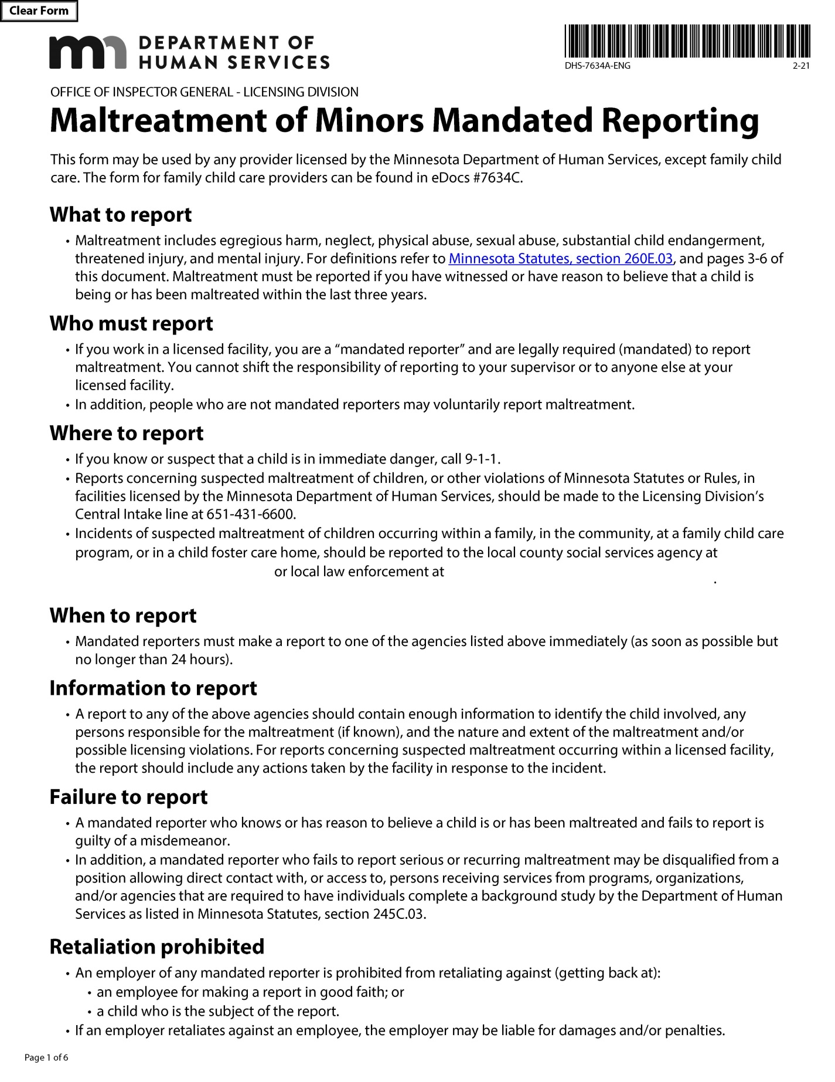
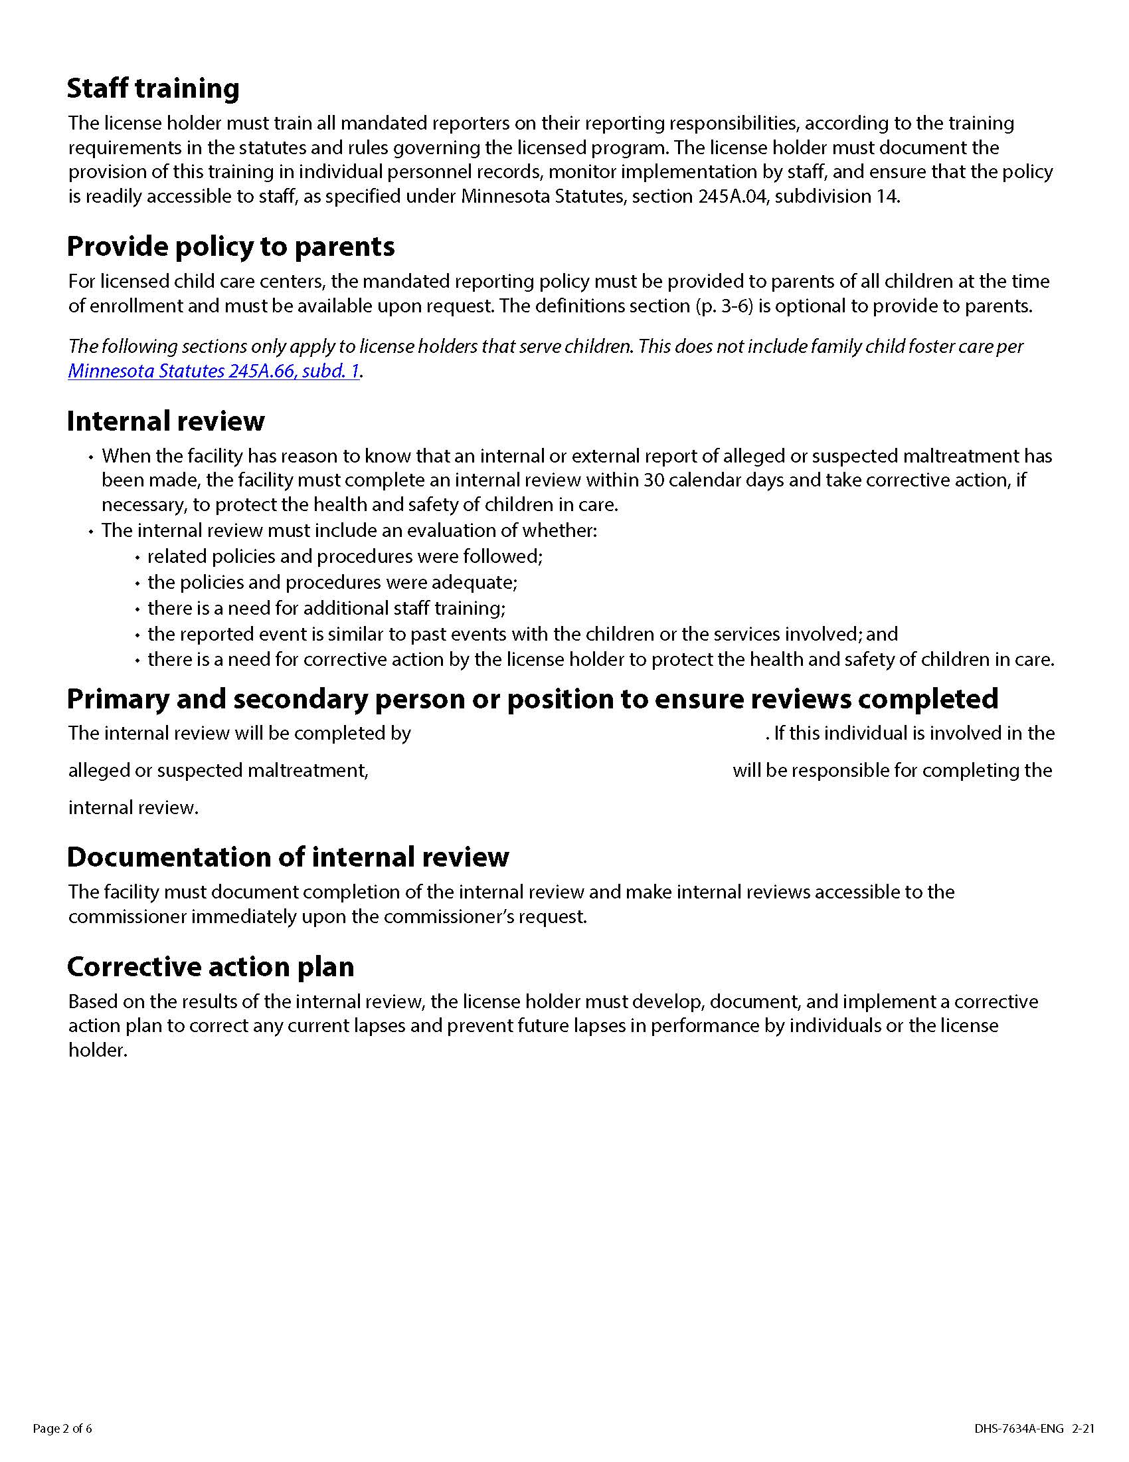
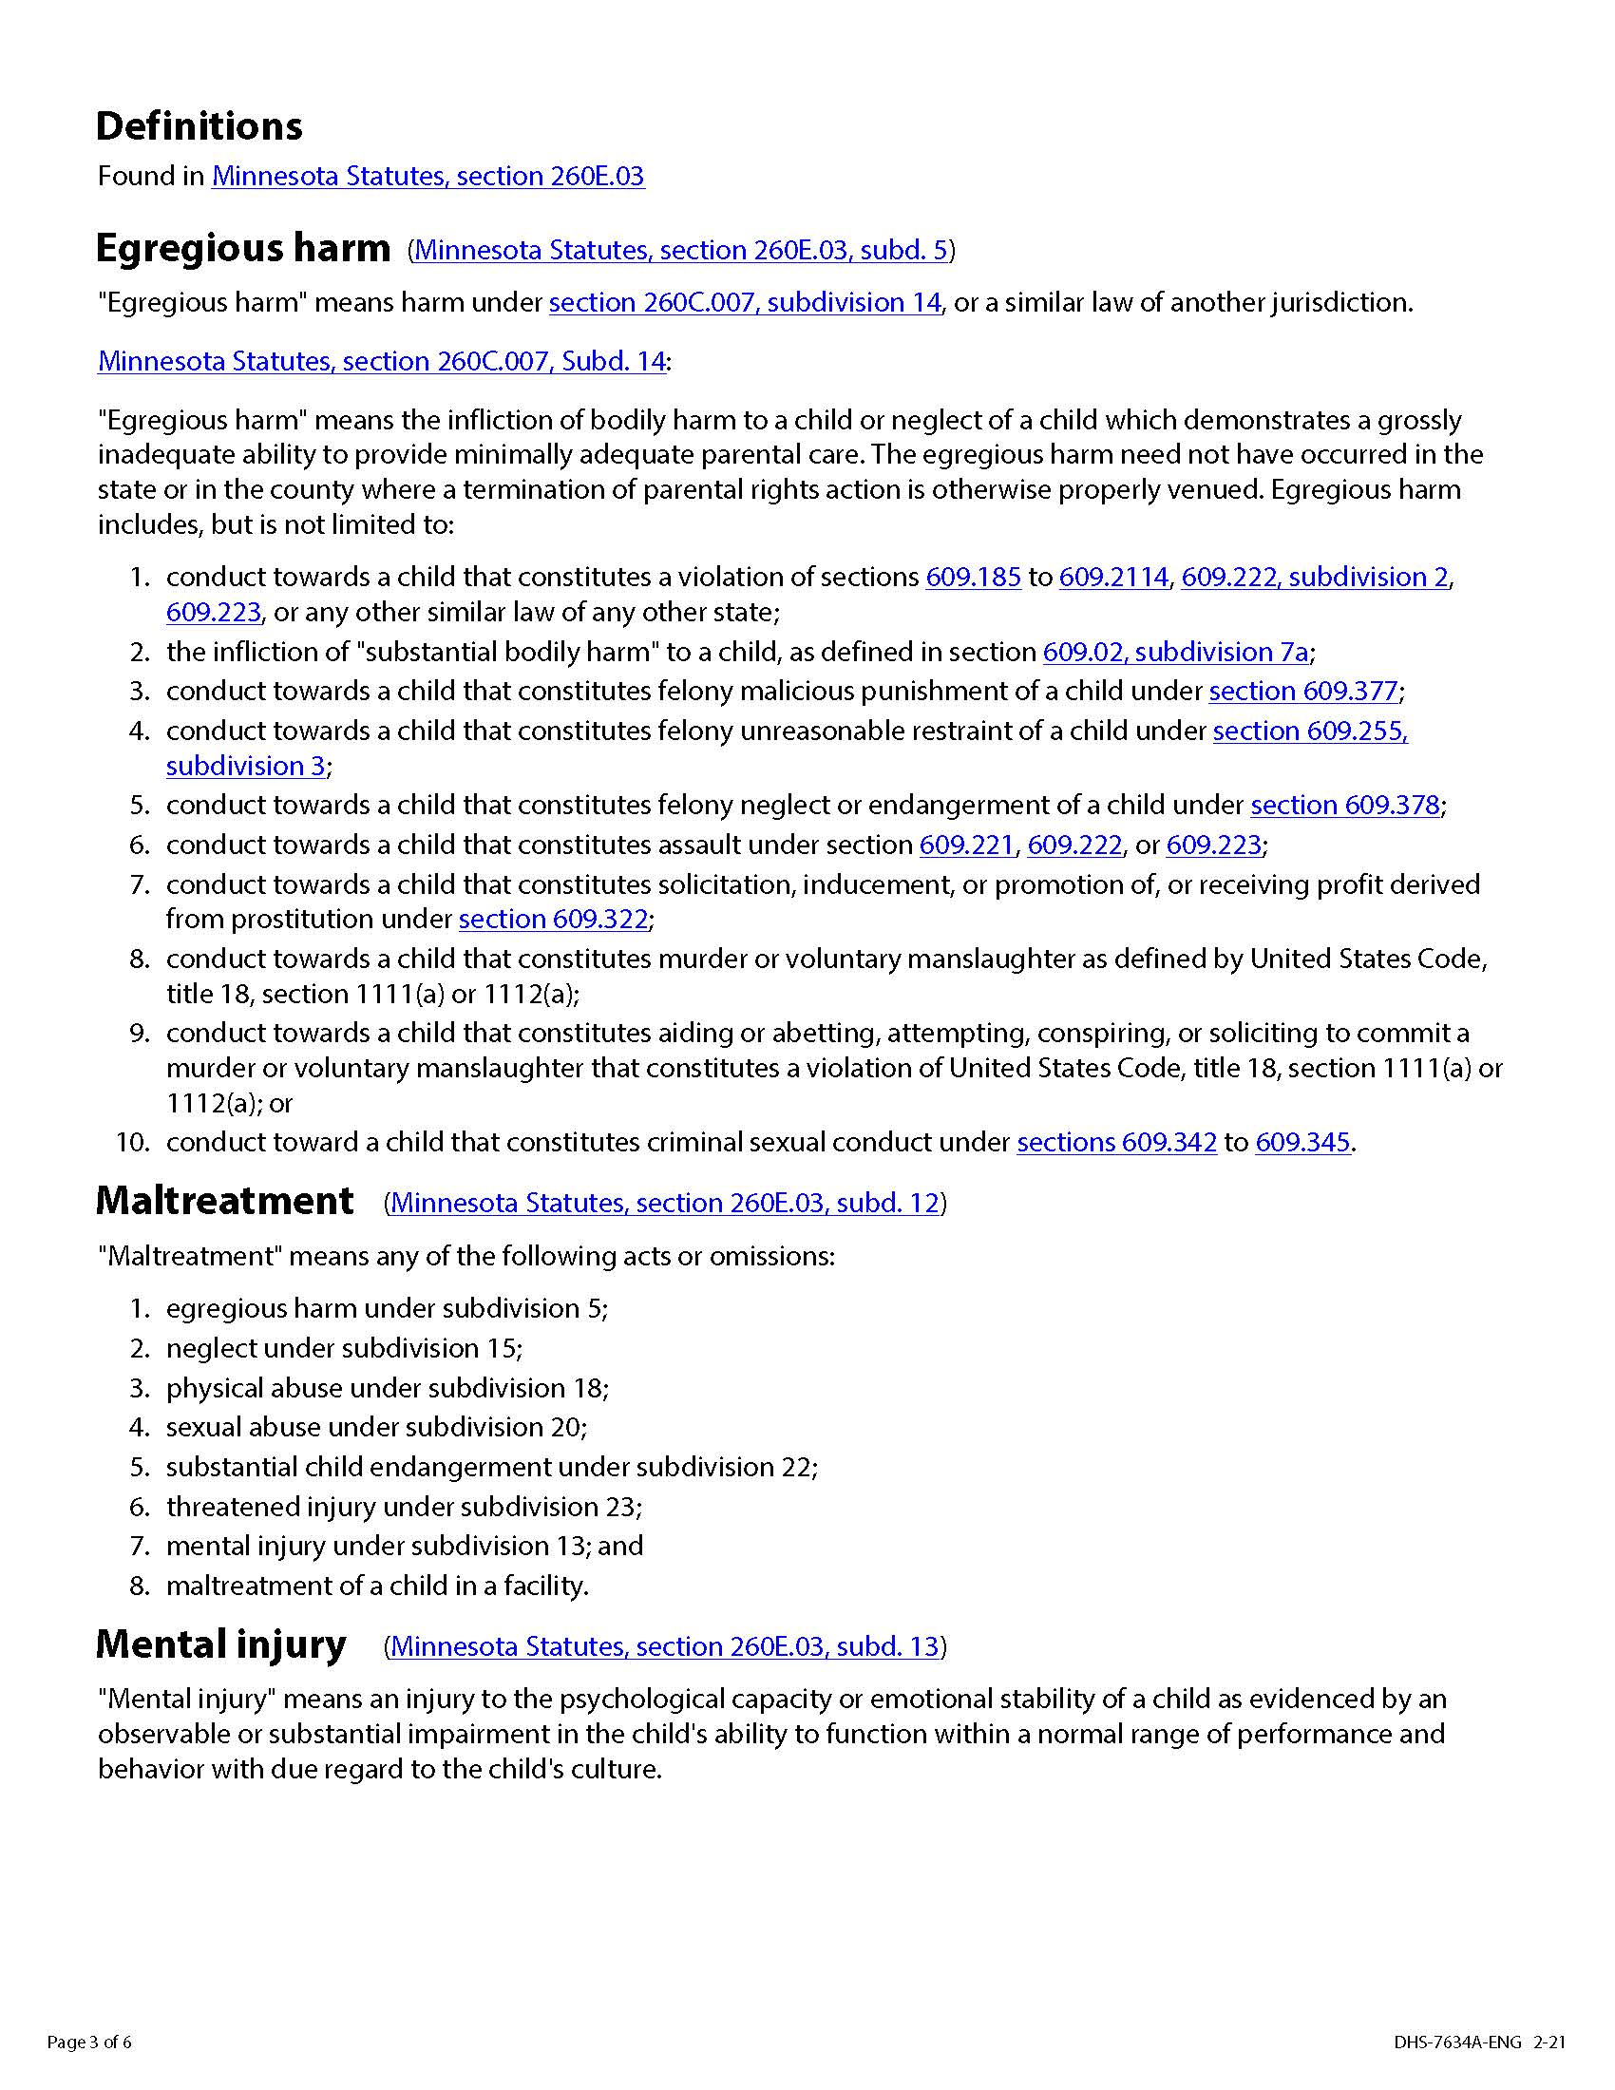
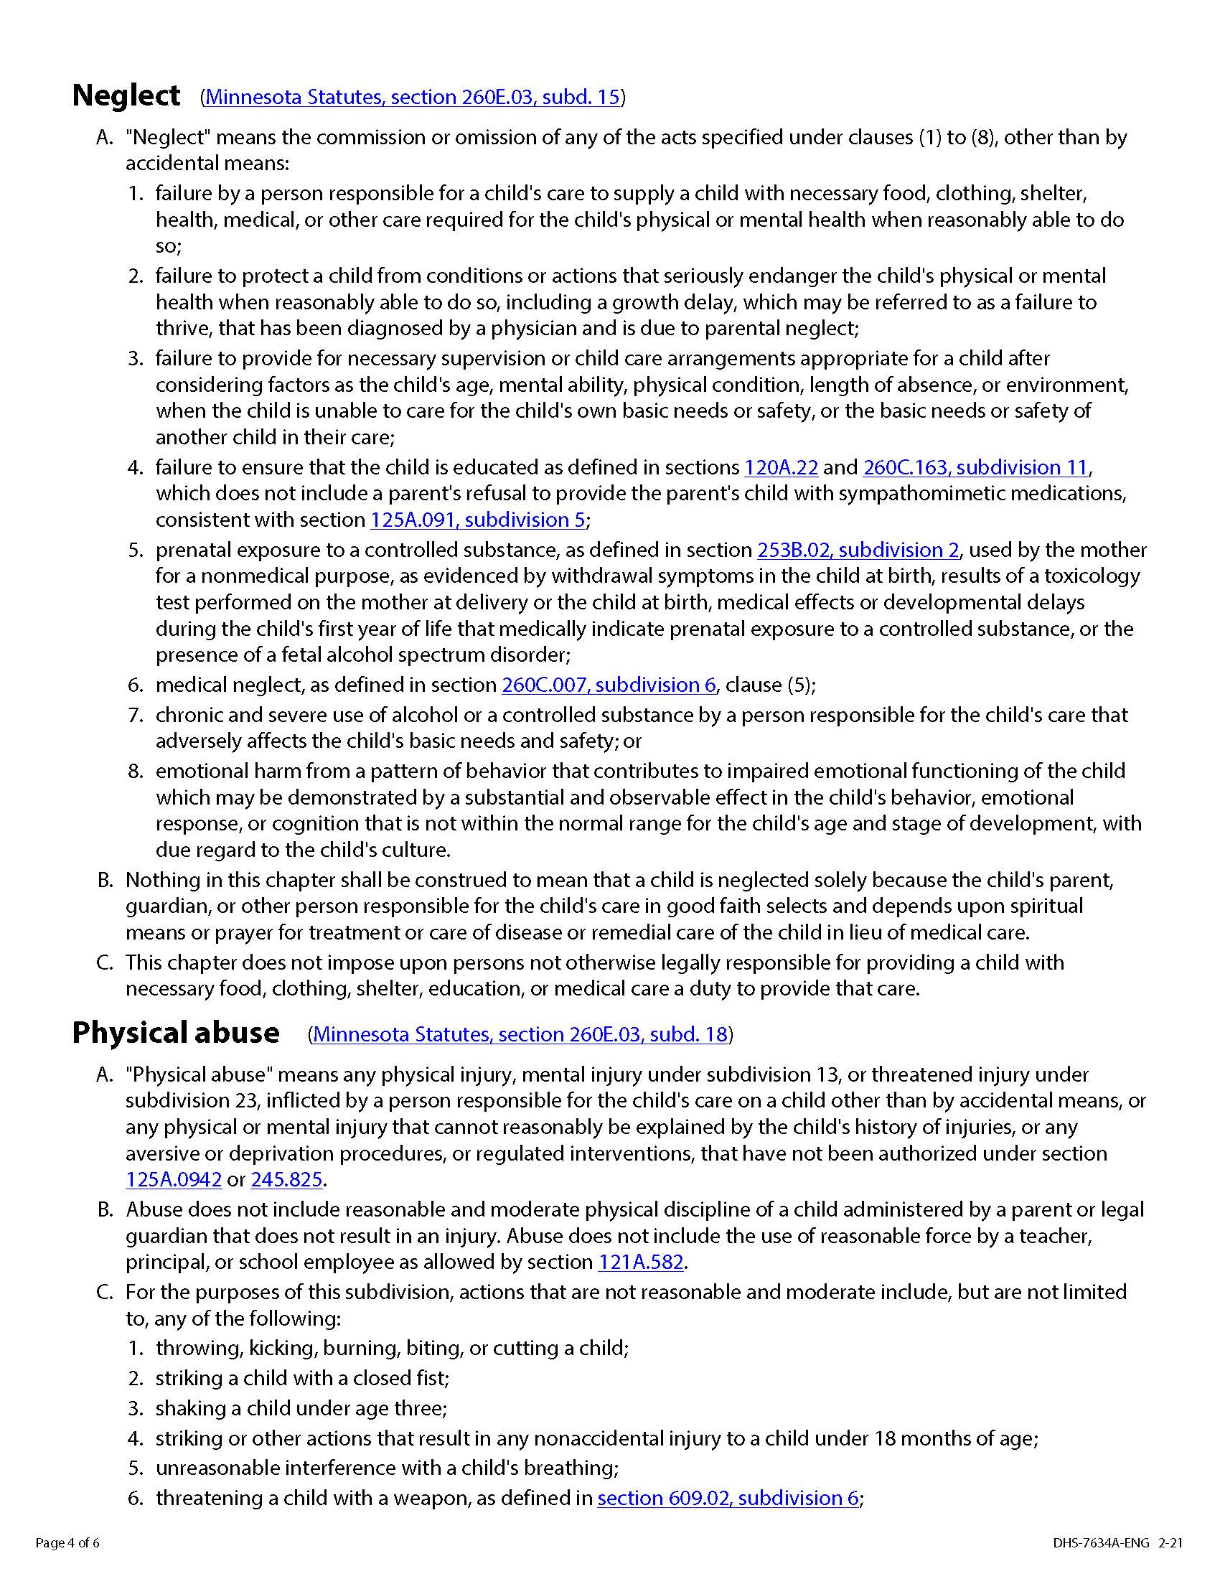
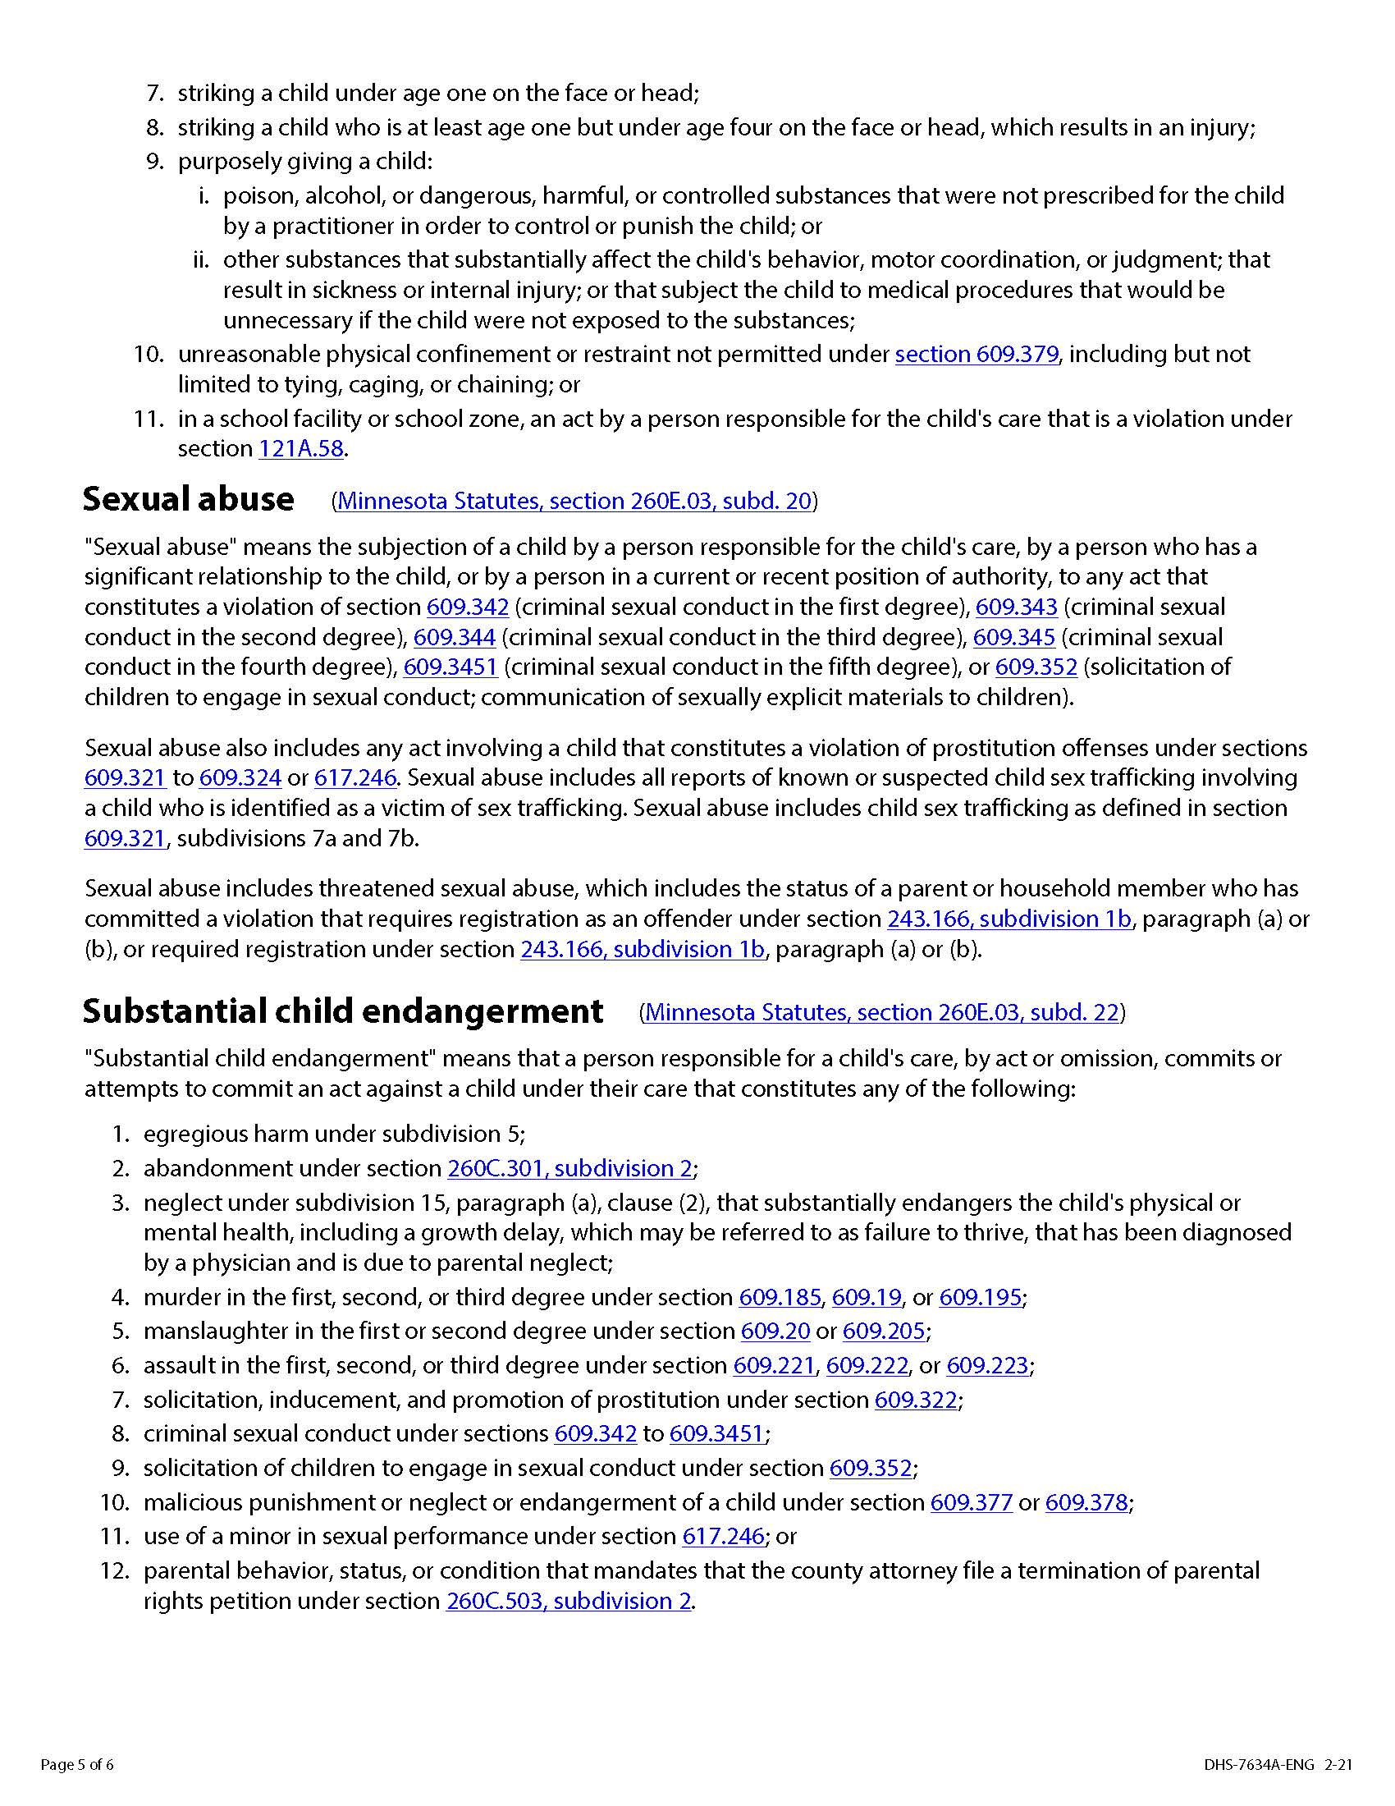
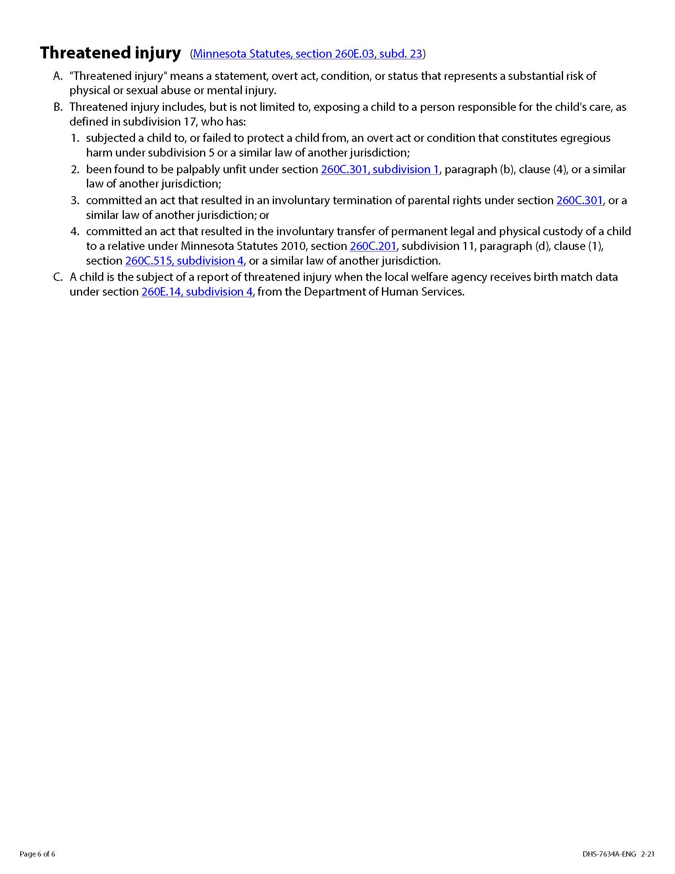
Way to Grow looks forward to creating a partnership
with your family to ensure that you and your children
receive the knowledge, resources, and support you need to prepare your children for kindergarten!

- I have received the Way to Grow Preschool Pals Family Handbook.
- I agree to follow the policies and procedures explained in the handbook regarding…
  - Immunizations, Emergency Cards, and Health Care Summaries
  - Attendance
  - Busing
  - Family Engagement
  - Referral for Services
  - Field Trips
  - Behavior Guidance
  - Health and Allergy Policies
  - Exclusion for Illness
  - Medications

Child’s name: ____________________________ Date: __________

Parent’s signature: __________________________________

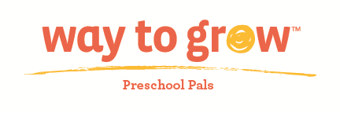

Family Handbook Agreement

- I have received the Way to Grow Preschool Pals Family Handbook.

- I agree to follow the policies and procedures explained in the handbook regarding…
  - Immunizations, Emergency Cards, and Health Care Summaries
  - Attendance
  - Busing
  - Family Engagement
  - Referral for Services
  - Field Trips
  - Behavior Guidance
  - Health and Allergy Policies
  - Exclusion for Illness
  - Medications

Child’s name: ____________________ Date: ____________

Parent’s signature:___________________________________

